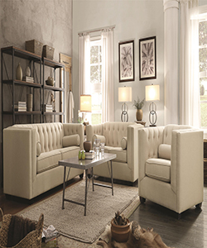

Living Room Sofa

$187.79

Availability: In stock

Description

Furnish your living room with this collection. Pieces include a sofa, love seat, and chair with great features such as tufted cushions, lumbar pillows, and reversible cushions. It is a Transitional Style, Reversible Seat Cushions with Welt Cords, Two Lumbar Pillows. Color range is available. Included Wood Block Legs. No assembly required - Product comes fully assembled.